

| **1. APT Project Progress Summary** |
| --- |
| Below, you will find various fields that you must complete with the requested information. |

| APT Project Progress Summary | During this second phase of the APT Project, significant progress was made in the development of the Happy Huapi SME website, focused on the digitization of its processes.  The stages of requirements gathering, interface design, and programming of the main modules, which include the digital catalog, the reservation system, and the administration view, were completed. The team worked applying agile methodology principles, making partial deliveries. |
| --- | --- |
| Objectives | * Develop a functional and manageable web solution for the SME Happy Huapi. * Implement a digital catalog, a quotation system, and a reservation management tool. |
| Methodology | An agile methodology based on Scrum was used, with follow-up meetings and review of deliverables. |
| Evidence of progress | For this progress report, the following elements are presented as main evidence:   1. **Screenshots of the system in operation**, showing:    * The administrator login.    * The management and updating of catalogs and products.    * The reservation and management of events by the user. 2. **Database registration in PostgreSQL**, showing that the information entered from the platform is stored correctly and reflected in the corresponding tables.   **Justification** This evidence allows us to account for the development of the project, as it tangibly shows the implementation of the main functionalities and the correct flow of data within the system. In addition, it reflects the progress made in the digitization of Happy Huapi's processes, fulfilling the objectives defined in the planning phase. |
| **2. Monitoring the Work Plan** |
| Carefully examine your work plan, focusing especially on the progress status and adjustments column. |

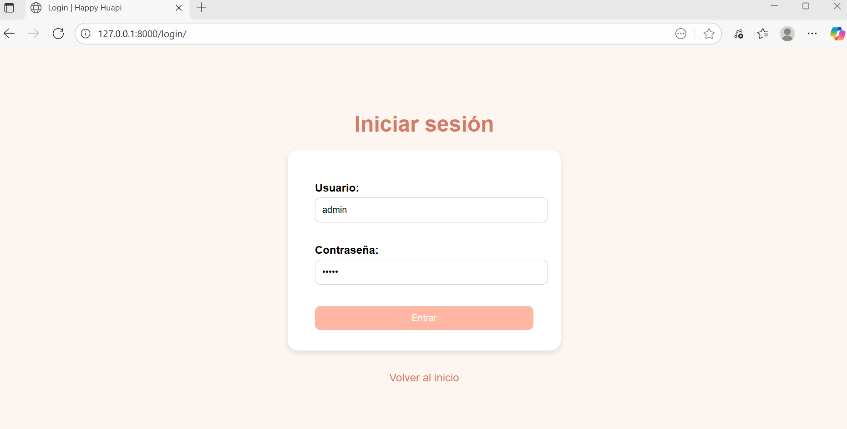

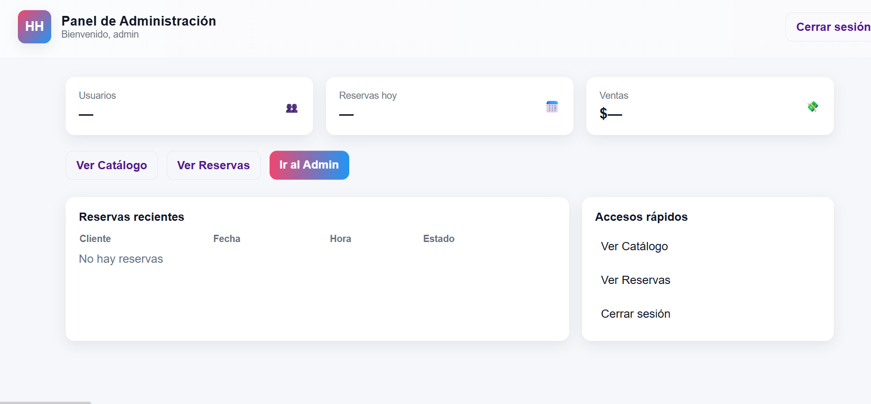

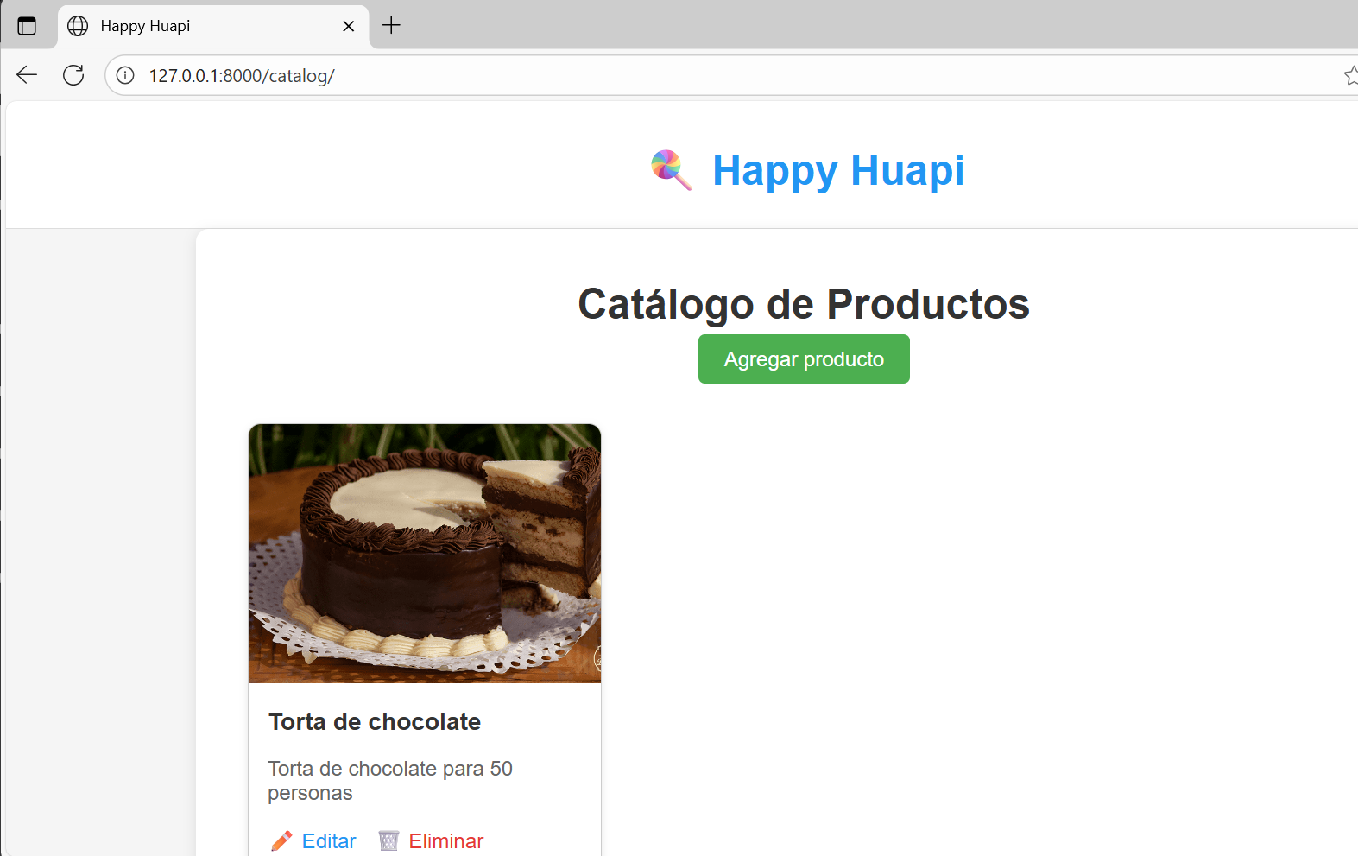

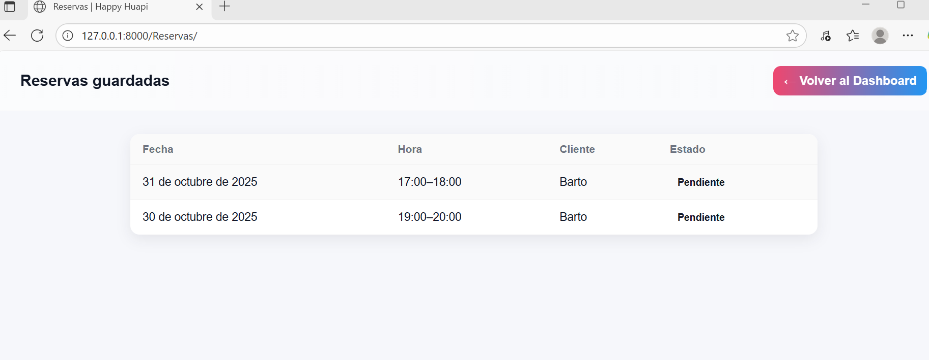

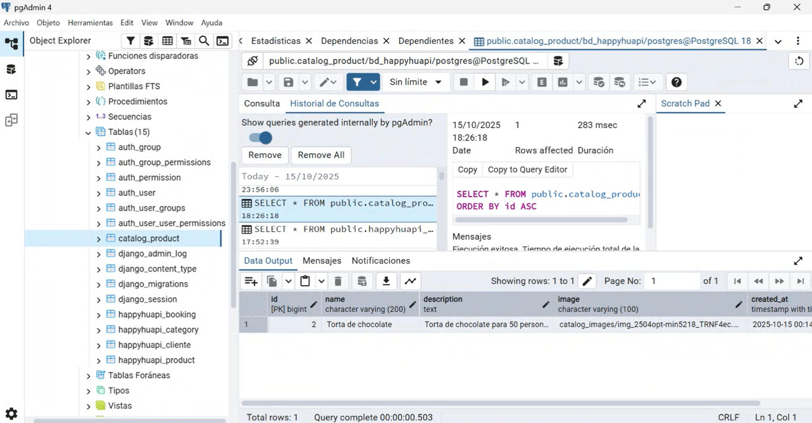

| Work Plan | | | | | | | |
| --- | --- | --- | --- | --- | --- | --- | --- |
| Competency or competency units | Activities | Resources | Duration of activity | Responsible | Comments | Progress | Adjustments |
| Analyze and gather requirements | Meeting with client and gathering requirements | Articles of incorporation, requirements matrix, computer, internet connection. | 1 week | Daniel Briones | The client's availability could make coordination difficult, but this process facilitates clarity regarding the scope of the project. | Completed | No adjustments |
| Design digital solutions | Developing the interface prototype and defining the user flow. | Design tools (Figma, Canva). | 2 weeks | Ignacio Venegas | Requires constant validation with the client to avoid rework. | Completed | No adjustments |
| Develop web applications | Implementation of the digital catalog to display products and services organized by category. | Languages: HTML, CSS, Python, Django framework. | 2 weeks | Cristóbal Navarrete | Work is underway to improve the visual appearance of the catalog and integrate it with the administration panel. | In progress | No adjustments |
| *Develop web applications* | Programming the online quotation system using dynamic forms. | Development frameworks, form libraries, PostgreSQL database. | 2 weeks | Ignacio Venegas | Requires testing with real data to validate functionality. | In progress | No adjustments |
| Build and manage data models | Development of the reservation management and schedule availability module. | Database, hosting, calendar libraries. | 2 weeks | Cristóbal Navarrete | Integration with the catalog could pose a technical challenge, but it is key to the organization of the SME. | In progress | No adjustments |
| Apply agile project management methodologies | Review progress and present partial deliverables to the client for feedback. | Management dashboard (Trello/Notion), virtual or face-to-face meetings. | 2 weeks | Daniel Briones | Timely feedback from the client facilitates continuous improvement of the project. | Ongoing | No adjustments |
| Perform testing and quality control | Functionality testing and verification of operation in different browsers. | Web browsers, testing plan. | 1 week | Cristóbal Navarrete | Minor adjustments may be necessary depending on the results, but they guarantee a reliable product. | In progress | No adjustments |

| **3. Adjustments based on monitoring** |
| --- |
| Take a closer look at the observations in your work plan. Analyze the planned activities and point out which aspects facilitated or hindered the execution of the plan. Discuss how you addressed and/or will address the obstacles. Finally, point out the adjustments you made to the work plan based on this analysis. |

| Factors that facilitated and/or hindered the development of my work plan:  The development of the project was facilitated by good team coordination and constant feedback, which allowed us to maintain a clear view of progress and prioritize tasks correctly. Among the factors that have partially hindered development are certain technical challenges associated with the integration of different modules, such as the catalog and the reservation system. However, these situations were addressed through timely communication within the team and the search for documented technical solutions, avoiding major delays. |
| --- |

| Adjusted or eliminated activities:  No adjustments or eliminations were made within the work plan. All activities were carried out as planned, thanks to an adequate distribution of tasks and effective coordination among team members. |
| --- |

| Activities that have not been started or are delayed:  Some activities are still in progress, such as functionality testing and module optimization. The slight delays in these tasks are due to the need for visual adjustments and integration testing to ensure system stability.  We plan to continue these activities over the coming weeks, holding internal review meetings to ensure that deadlines are met and the final product is of high quality. |
| --- |